**Nama : Estu Nosita**

**Nim : 18090070**

**Kelas : 5C**

**TUGAS PERTEMUAN 2**

* **Materi**

1. **View-latihan2.php**
2. **Source Code**

**view-latihan2.php 🡪 application/views**

1. **Model1.php**
2. **Source Code**

**Model1.php 🡪 application/models**

1. **Latihan1.php**
2. **Source Code**

**Latihan1.php 🡪 application/controllers**

1. **URL**

http://localhost/pustaka_booking_estu/index.php/Latihan1/penjumlahan/5/10

1. **Capture Hasil**

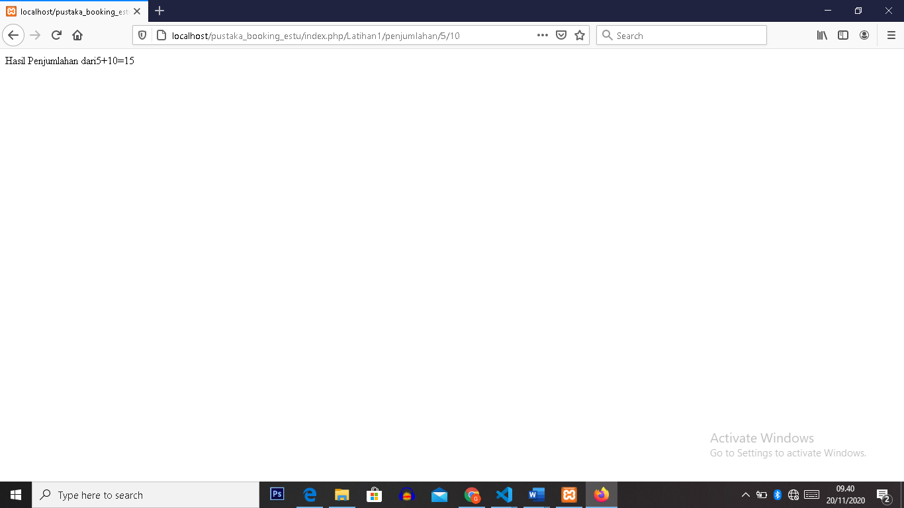

1. **Latihan2.php**
2. **Source Code**

**Latihan2.php 🡪 application/controllers**

1. **URL**

http://localhost/pustaka_booking_estu/index.php/Latihan2/penjumlahan/5/10

1. **Capture Hasil**

